Videó riport
https://www.youtube.com/watch?v=VhtRztC0KWo
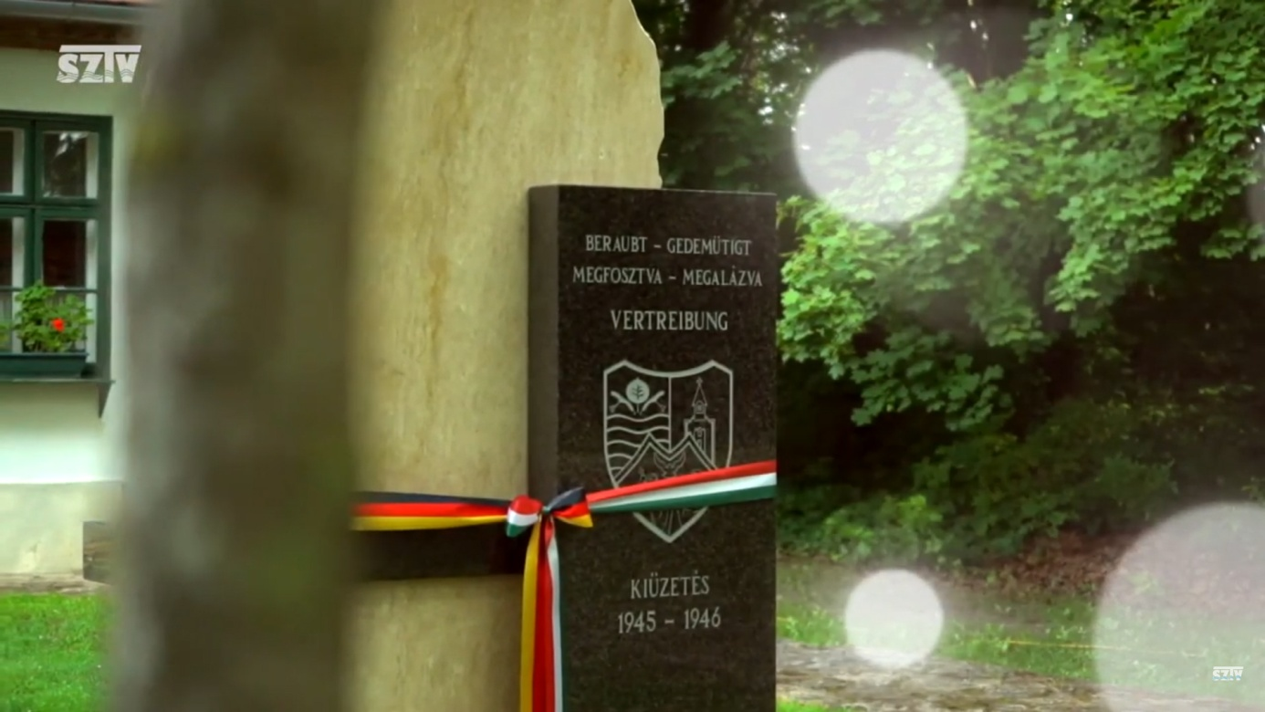https://www.youtube.com/watch?v=VhtRztC0KWo

